**Circuit:**

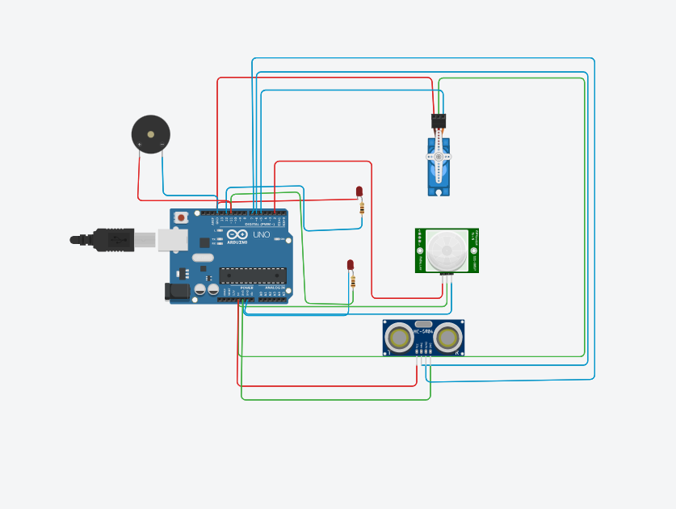

**Code:**

#include <Servo.h>

Servo a;

int trigger=6;

int echo=7;

int motion=2;

int led1=3;

int led2=4;

void setup()

{

Serial.begin(9600);

pinMode(trigger,OUTPUT);

pinMode(echo,INPUT);

pinMode(motion,INPUT);

pinMode(led1,OUTPUT);

pinMode(led2,OUTPUT);

a.attach(5);

a.write(0);

digitalWrite(led1,LOW);

digitalWrite(led2,LOW);

}

void loop()

{

int p = digitalRead(motion);

if(p)

{

digitalWrite(led1,HIGH);

digitalWrite(led2,HIGH);

tone(11,5000);

delay(5000);

digitalWrite(led1,LOW);

digitalWrite(led2,LOW);

noTone(11);

}

digitalWrite(trigger,LOW);

digitalWrite(trigger,HIGH);

delayMicroseconds(10);

digitalWrite(trigger,LOW);

float duration = pulseIn(echo,HIGH);

float dist = (duration*0.0343)/2;

if(dist<50)

{

a.write(90);

delay(5000);

a.write(0);

}

}